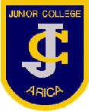
Junior College
Arica ,Chile

My first pictionary

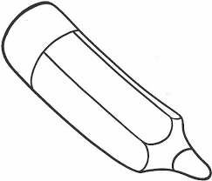

Name: ________________________________________
Grade:________________________________________
Age: __________________________________________
Year: _________________________________________

The colors

- Blue

- Red

- Yellow

- Green

- Pink

- White

- Sky blue

- Black

- Orange

- Gray

- Purple

- Brown

The Numbers

- One
- Two
- Three
- Four
- Five
- Six
- Seven
- Eight
- Nine
- Ten
- Eleven
- Twelve
- Thirteen
- Fourteen
- Fifteen
- Sixteen

The school objects

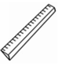
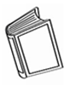
- Book 8) Ruler

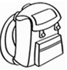
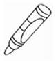
- Crayon 9) School bag

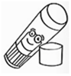
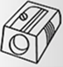
- Glue 10) Sharpener

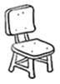
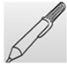
- Pen 11) Chair

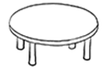
- Pencil 12) Table

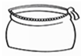
- Pencil case 13) Scissors

- Rubber

My family

- Granny 5) Grandad

- Mum 6) Dad

- Sister 7) Brother

- Baby 8) Pet

Party objects

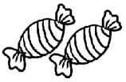
- Balloons 5) Candy

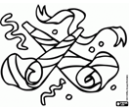
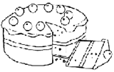
- Cake 6) Blower

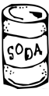
- Candles 7) Soda

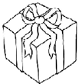
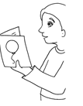
- Present 8) Card

My birthday party

My pets

- Turtle 5) Spider

- Bird 6) Lizard

- Cat 7) Dog

4) Rabbit 8) Goldfish

9) Hamster 11) Rat

10) Parrot 12) Frog

Pet shop

My toys

1) Ball 5) Bike

2) Car 6) Doll

3) Teddy 7) Kite

4) Computer game 8) Plane

9) Train 13) Scooter

10) Robot 14) Truck

11) Skip rope 15) Skateboard

12) Rollerblade 16) Yo- yo

My house
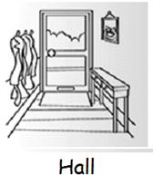
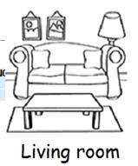
- 5)

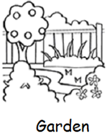
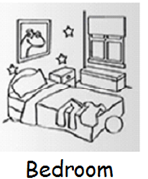
- 6)

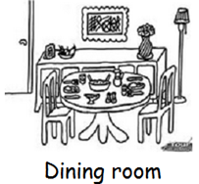
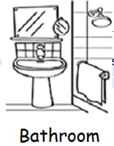
- 7)

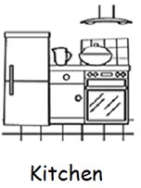
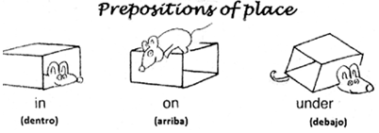
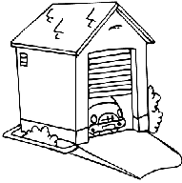
- 8)

Objects of the house

- Chair 5) Toilet

- Sofa 6) Bath

- Picture 7) Fridge

- Lamp 8) Table

- T.V 12) Flower

- Bed 13) Plant

- Plant

My house

My body

- ___________________ 7) ___________________
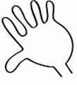
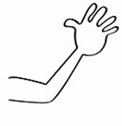

- ___________________ 8) ___________________
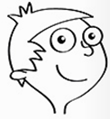

- ___________________ 9) ___________________

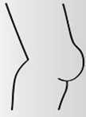
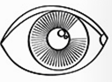

- ___________________ 10) ___________________
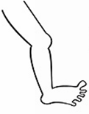
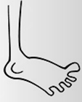

- ___________________ 11) ___________________
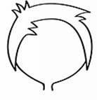
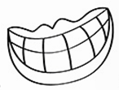

- ___________________ 12) ___________________

Actions

- _______________________ ) _____________________
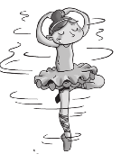
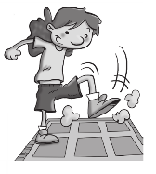

- _______________________ ) _____________________
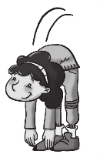

3) _______________________ ) _____________________
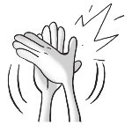
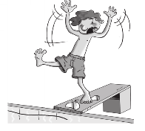

4) ________________________________________________

